Spring framework

### what is spring framework🧩

### ****Definition****

* **Spring Framework** is a lightweight framework that provides support for developing Java applications. It helps developers build robust, maintainable, and loosely coupled applications.

### ⚙️ ****Core Features****

Here are the main features that make Spring so popular:

1. **Inversion of Control (IoC)**

* The heart of the Spring Framework.
* Instead of the developer creating and managing objects manually, the **Spring Container** creates and manages them for you.
* This is also called **Dependency Injection (DI)**.  
  Example:

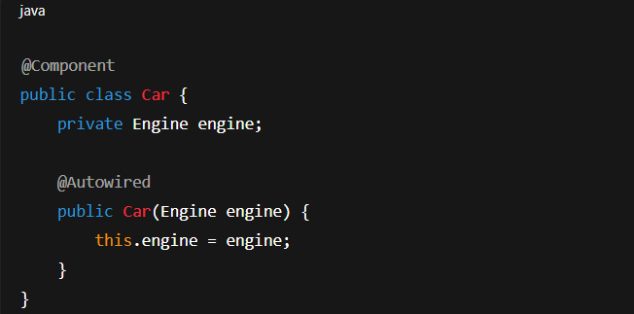

👉 Here, Spring automatically injects the Engine object into Car.

**2.Aspect-Oriented Programming (AOP)**

* Allows separating cross-cutting concerns (like logging, security, and transactions) from business logic.

Example: You can log method calls without writing log statements in every method

**3.Spring MVC (Model-View-Controller)**

* Used for building **web applications**.
* Separates application logic, user interface, and input control — making code clean and maintainable.

**4.Spring Data**

* Simplifies database access with **JPA, Hibernate**, or even NoSQL databases like MongoDB.
* Automatically generates CRUD operations.

**5.Spring Security**

* Provides authentication, authorization, and protection against common attacks (like CSRF).

**6.Spring Boot**

* Built on top of the Spring Framework.
* Makes it easy to **create stand-alone Spring applications** with minimal configuration.
* You can start a project with embedded Tomcat and run it just like a normal Java app.

### 🧱 ****Architecture Overview****

Spring Framework is divided into **modules**, such as:

1.Core Container (Beans, Core, Context)

2.AOP (Aspect-Oriented Programming)

3.Data Access/Integration (JDBC, ORM, Transactions)

4.Web (Spring MVC, WebSocket)

5.Test (unit and integration testing)

The **Spring Framework** is made up of several **modules** — each providing specific functionality.  
These modules work together to build powerful Java enterprise applications but can also be used independently.

Let’s break down all the **main Spring modules** (with clear explanation):

## 🌿 ****1. Core Container Modules****

These are the foundation of the entire Spring Framework.

| **Module** | **Description** |
| --- | --- |
| **spring-core** | Contains the core parts of the framework, like the **IoC (Inversion of Control)** and **Dependency Injection** mechanisms. |
| **spring-beans** | Provides the **BeanFactory** — the container that manages application objects (beans). |
| **spring-context** | Provides access to objects in a framework-style manner, similar to a JNDI registry. The **ApplicationContext** interface is part of this module. |
| **spring-expression (SpEL)** | The **Spring Expression Language** allows querying and manipulating object graphs at runtime (e.g., #{student.name} inside configurations). |

💡 Together, these modules handle how beans are created, configured, and managed by Spring.

## ⚙️ ****2. Data Access / Integration Modules****

These modules handle database and transaction management.

| **Module** | **Description** |
| --- | --- |
| **spring-jdbc** | Simplifies JDBC (Java Database Connectivity) — removes the need for writing repetitive boilerplate code like opening/closing connections. |
| **spring-tx (Transactions)** | Manages transactions declaratively (using annotations like @Transactional). |
| **spring-orm** | Integrates ORM frameworks like **Hibernate**, **JPA**, and **JDO** with Spring. |
| **spring-oxm** | Supports Object-to-XML mapping (using JAXB, Castor, etc.). |
| **spring-jms** | Provides features for producing and consuming messages using Java Message Service (JMS). |

## 🌐 ****3. Web Modules****

These modules are used to build **web-based applications**.

| **Module** | **Description** |
| --- | --- |
| **spring-web** | Provides basic web-oriented features and integration with multipart file uploads and servlet listeners. |
| **spring-webmvc** | Implements the **Model-View-Controller (MVC)** design pattern — for building web applications. (Also known as Spring MVC.) |
| **spring-webflux** | Supports **reactive programming** — used to build **non-blocking, asynchronous web applications**. |

## 🧩 ****4. AOP (Aspect-Oriented Programming) and Instrumentation Modules****

| **Module** | **Description** |
| --- | --- |
| **spring-aop** | Supports **Aspect-Oriented Programming (AOP)** — lets you define cross-cutting concerns like logging, transactions, and security separately from business logic. |
| **spring-aspects** | Integrates AspectJ (a popular AOP framework) into Spring. |
| **spring-instrument** | Provides class instrumentation support and classloader implementations used in some servers. |

## 🧪 ****5. Test Module****

| **Module** | **Description** |
| --- | --- |
| **spring-test** | Supports unit testing and integration testing with frameworks like **JUnit** and **TestNG**. It can load Spring ApplicationContext for testing. |

## 🌸 ****6. Spring Boot and Other Projects (Built on Top of Core Spring)****

Although not part of the core framework, these are **Spring ecosystem projects** that extend its functionality:

| **Project** | **Description** |
| --- | --- |
| **Spring Boot** | Simplifies Spring application development with auto-configuration and embedded servers. |
| **Spring Security** | Provides authentication, authorization, and protection from common attacks (CSRF, XSS). |
| **Spring Data JPA** | Simplifies database operations — automatically generates queries. |
| **Spring Cloud** | Builds distributed and cloud-based microservices easily. |
| **Spring Batch** | For processing large volumes of data (batch jobs). |
| **Spring Integration** | Helps integrate different enterprise systems. |

### 🏗️ ****Why Use Spring?****

✅ Reduces boilerplate code  
✅ Encourages clean architecture (loose coupling)  
✅ Supports integration with other frameworks  
✅ Provides powerful data handling and transaction management  
✅ Great for microservices (via Spring Boot + Spring Cloud)

## 🌿

## ****1.What is IoC (Inversion of Control)?****

**Inversion of Control (IoC)** means —

* Instead of your code creating and managing objects manually, the **Spring Framework creates and manages them for you.**

In other words:

* Normally, in Java, we write:

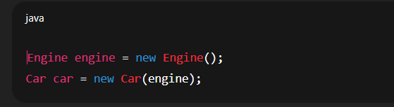

· ➤ Here **you** are controlling object creation.

· In Spring:

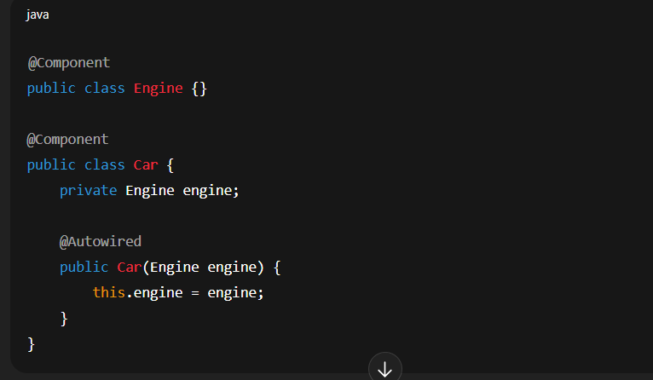

➤ Here, **Spring** creates both Engine and Car objects and **injects** the dependencies automatically.

That “object creation and injection” is done by the **Spring IoC Container.**

## 🧩

## ****2.What is Spring IoC Container?****

The **IoC Container** is the **core part of the Spring Framework** responsible for:

✅ Creating objects (beans)  
✅ Managing their lifecycle  
✅ Injecting dependencies between them  
✅ Managing configuration (from XML, annotations, or Java classes)

💡 The container reads configuration (like @Component, @Configuration, or XML) to know which classes to instantiate and how to wire them.

## 3.****Types of Spring IoC Containers****

Spring provides **two main types** of IoC containers:

| **Container** | **Interface** | **Description** |
| --- | --- | --- |
| **BeanFactory** | org.springframework.beans.factory.BeanFactory | Basic container — provides fundamental IoC features. Lazy loads beans (creates only when needed). |
| **ApplicationContext** | org.springframework.context.ApplicationContext | Advanced container — builds on BeanFactory, supports enterprise features like event propagation, internationalization, AOP, etc. Eager loads beans (creates at startup). |

In most modern applications, **ApplicationContext** is used.

### Example of Both:

#### ****BeanFactory Example****

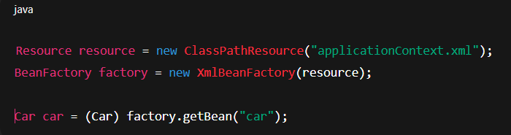

#### b) ****ApplicationContext Example****

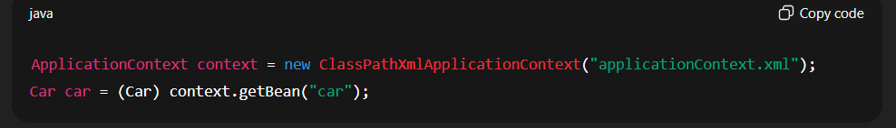

👉 **ApplicationContext** is preferred because it automatically handles resource

management and event handling.

## ⚙️ 4.****How the IoC Container Works (Step-by-Step)****

Let’s break it down:

### Step 1 — Configuration

* Spring needs configuration to know **which beans to manage**.
* Example:  
  **XML Configuration**

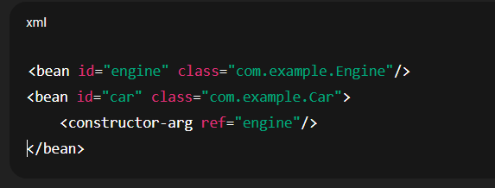

**OR Annotation Configuration**

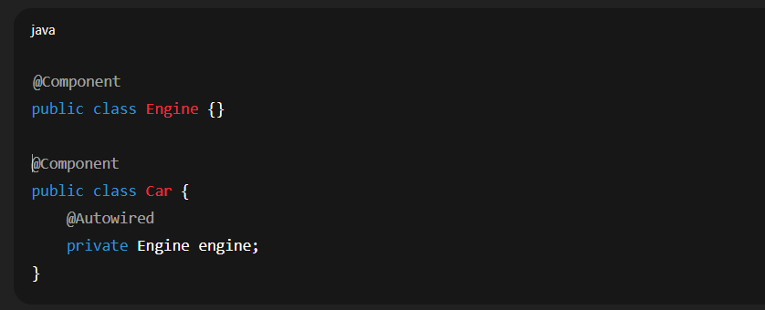

### Step 2 — Container Starts

* When the application starts:
* Spring reads the configuration (XML or annotations)
* It scans for bean definitions
* It creates objects (beans)

### Step 3 — Dependency Injection

* The container identifies dependencies (e.g., Car needs Engine)  
  and **injects** them automatically using:
* Constructor Injection
* Setter Injection
* Field Injection

### Step 4 — Bean Lifecycle Management

* The IoC container manages the complete **lifecycle of beans**:
* Bean Instantiation (object created)
* Dependency Injection
* Initialization (@PostConstruct or init-method)
* Usage (bean is ready)
* Destruction (@PreDestroy or destroy-method)

## ****5️⃣.Types of Dependency Injection (DI)****

| **Type** | **Example** | **Description** |
| --- | --- | --- |
| **Constructor Injection** | Inject through constructor | Most recommended (for immutability) |
| **Setter Injection** | Inject through setter method | Used when dependency is optional |
| **Field Injection** | Inject directly on fields using @Autowired | Convenient but less testable |

Example:

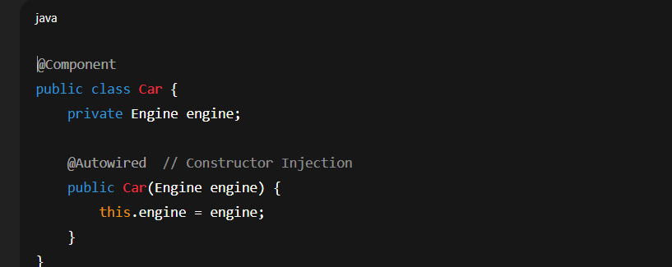

## 🔄 6.****IoC Container Diagram****

